CU RoboSub Team

8/8/2018

Power Board V2

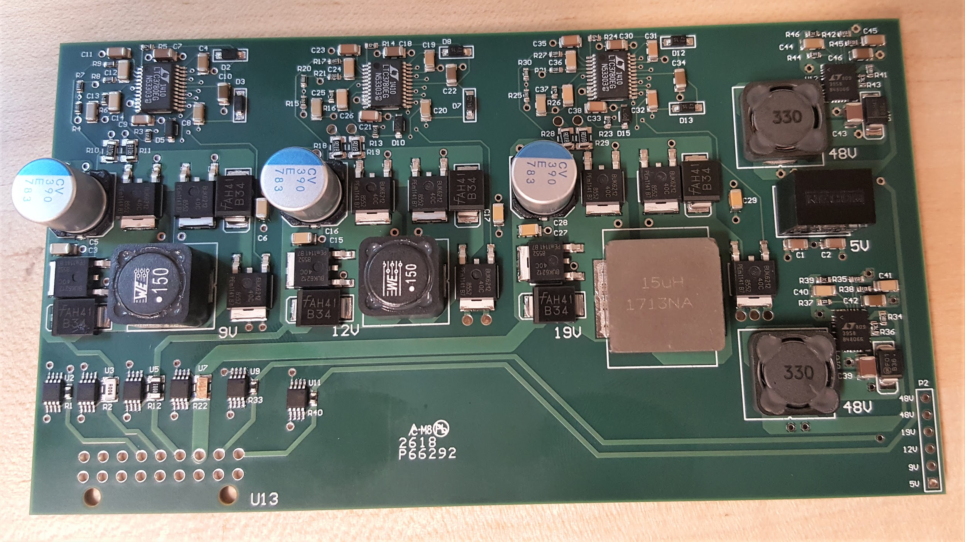

**Abstract** **3**

**Design Requirements** **3**

**Design Overview** **3**

Previous designs 3

**System descriptions** **4**

5V line 5

9V line 6

12V line 7

19V line 8

48V line 9

**System status** **9**

**Known Issues** **9**

**Appendix** **10**

# 

# Abstract

The power conversion board takes in approximately 14.8V from the merge circuit board through the backplane and converts it into various voltage levels to power each of the other electrical systems on the UAV.

# Design Requirements

|  |  |
| --- | --- |
| Description | Specifications |
| 5V line | 1A buck - Backup Line for Various Systems |
| 9V line | 1A buck - Network Switch |
| 12V line | 3A buck - Hydrophones, Pneumatic Systems, and Pressure Sensor |
| 19V line | 4A boost - Computer |
| 48V line | .5A boost - Down Camera with POE Injector |
| 48V line 2 | .5A boost - DVL Power with ethernet splitting |

# Design Overview

This board went through several revisions before this version was published. The revisions mostly involved reconfiguring layouts of the 9,12, and 19V lines along with redesigns to follow good PCB routing practices. These voltage lines used the LTC3780 controller with the recommended array of passive and active components. The two 48V lines used the recommended configurations for the LTC3958. These recommended designs can be found in the respective data sheets on Linear Technology’s website linked in the appendix.

## Previous designs

Design V1.0 was not of sufficient quality. It had no reverse bias protection which caused it to fail when brought to competition, along with several thermal, efficiency, and consistency issues. However, the buck and boost converters had quality designs and were continued into the second revision. Despite the good designs, the 19V line could not power a new computer, primarily due to components that could not handle the full 4A and incorrect current limiting resistors. The sub’s computer is a major component of the system so this board had to be redesigned for proper operation of the AUV.

# System descriptions

Shown below is the completed power board design. Red represents top layer traces while blue represents bottom level traces. This board ended up being a four layer PCB in order to route power and ground planes more efficiently and to potentially improve thermals with extra copper pours. The power plane is represented by the yellow plane and the ground is the cyan plane that covers the entire board. Each subsystem will be described in full within the subsequent sections.

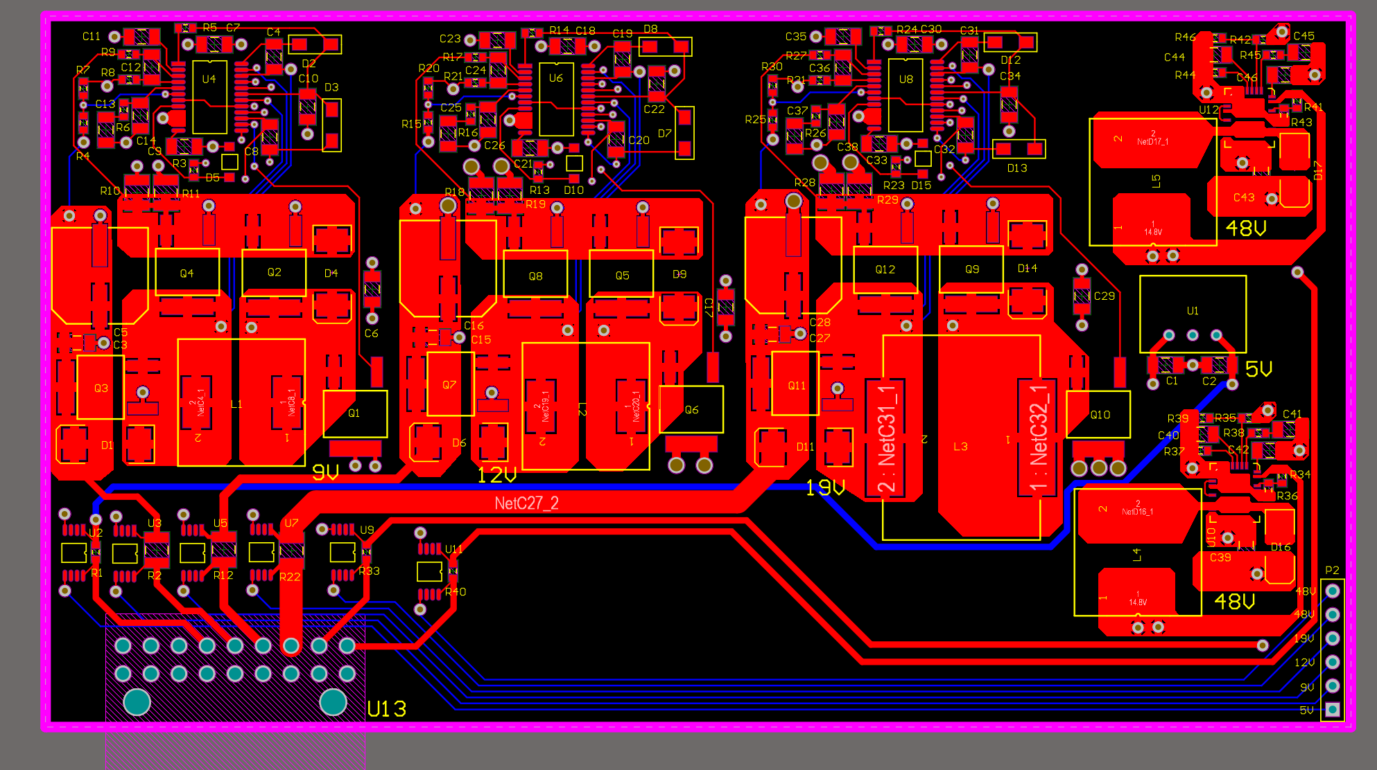

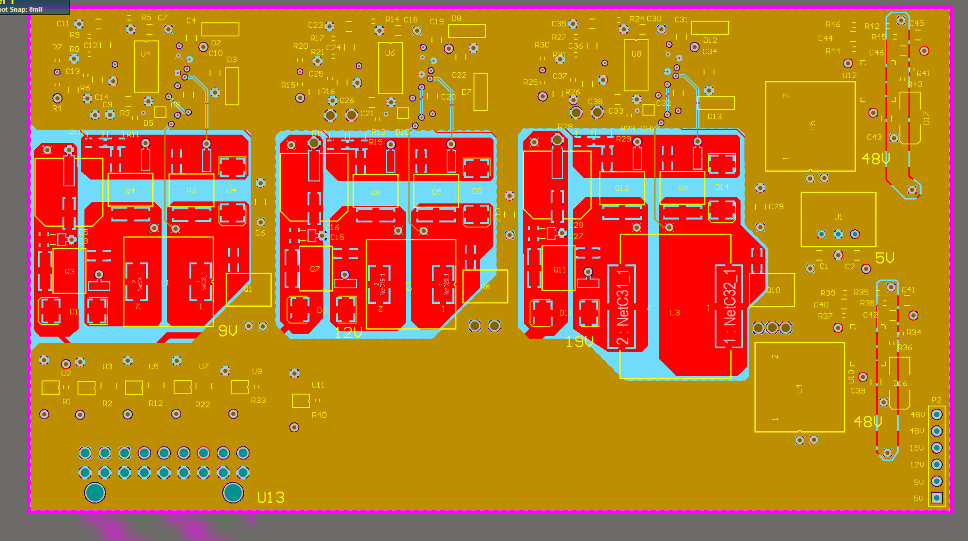

## 5V line

This systems consists of taking a R-78E-0.5 low cost switching regulator and adding a few decoupling capacitors to the input and output lines. Followed by a current sensing resistor with a AD8217 Analog Devices high resolution, zero drift current shunt monitor chip. This device utilizes a 10 mOhm sense resistor to measure current draw as linear voltage based on the current drop across the sense resistor.

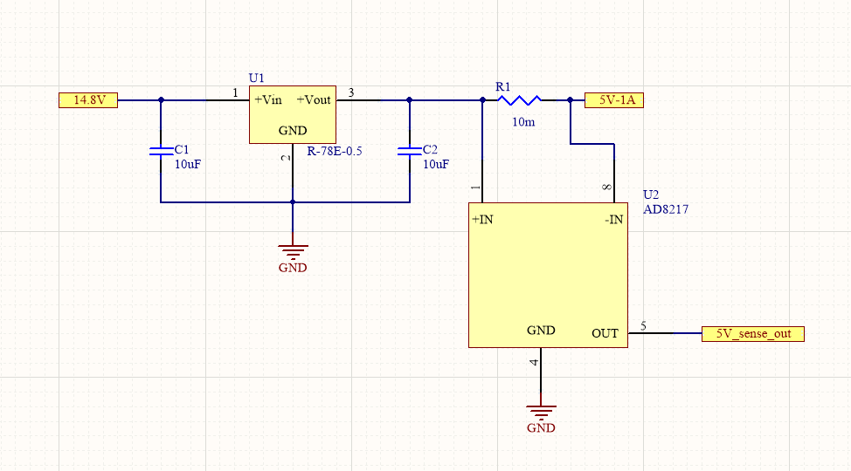

## 9V line

This systems consists of taking the LT3780’s recommended schematic, adding a few decoupling capacitors, and changing the Vosense resistors. The implemented Vosense resistors of 113kOhm and 11kOhm provide an output voltage of 9.02V. Reading the datasheet will be required for complete understanding of this IC. In brief, the voltage is modulated with an inductor and passed through external mosfets controlled by the IC’s oscillation cycles to allow for a variety of power requirements. This is all followed by a current sensing resistor with a AD8217. This device utilizes a 6mOhm sense resistor to measure current draw as linear voltage based on the current drop across the sense resistor.

The PCB layout of this circuit also follows the recommended design from the LT3780’s data sheet for optimal efficiency and ease of design. Due to the high current passing through some of the components, the component pad to polygon neck widths were increased from default, larger/duplicated vias were used to provide safe and sufficient power management, and output trace widths to the connector were increased based on online thermal and resistance calculators for PCB traces.

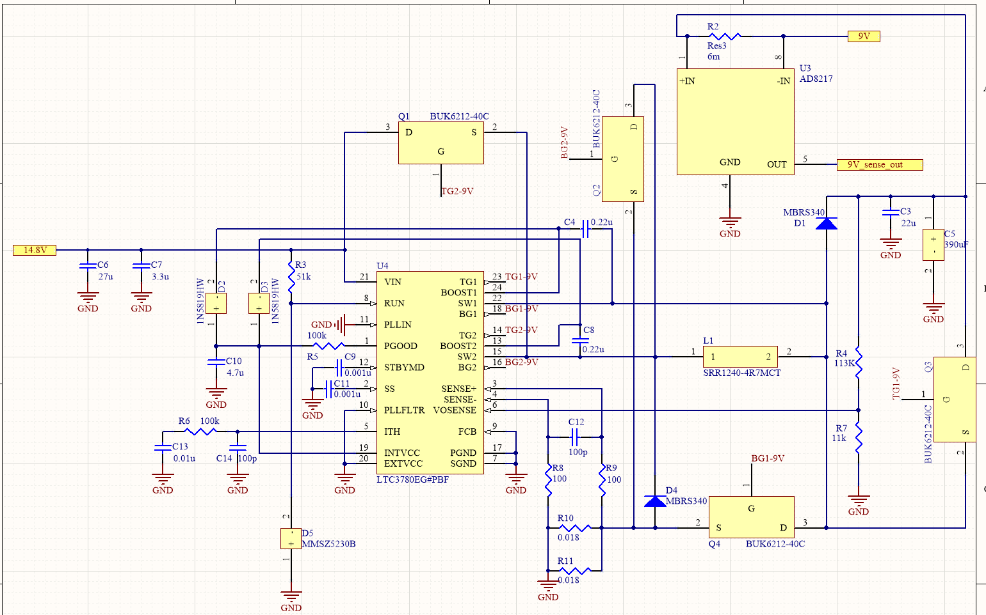

## 12V line

This systems consists of taking the LT3780’s recommended schematic, adding a few decoupling capacitors, and changing the Vosense resistors. The implemented Vosense resistors of 113kOhm and 8.06kOhm provide an output voltage of 12.02V. This line utilizes a 3mOhm sense resistor for its AD8217 to measure current draw as linear voltage based on the current drop across the sense resistor. The PCB layout of this circuit also follows the recommended design from the LT3780’s data sheet for optimal efficiency and ease of design. For further questions refer to the 9V line for a summary of this system since they are identical.

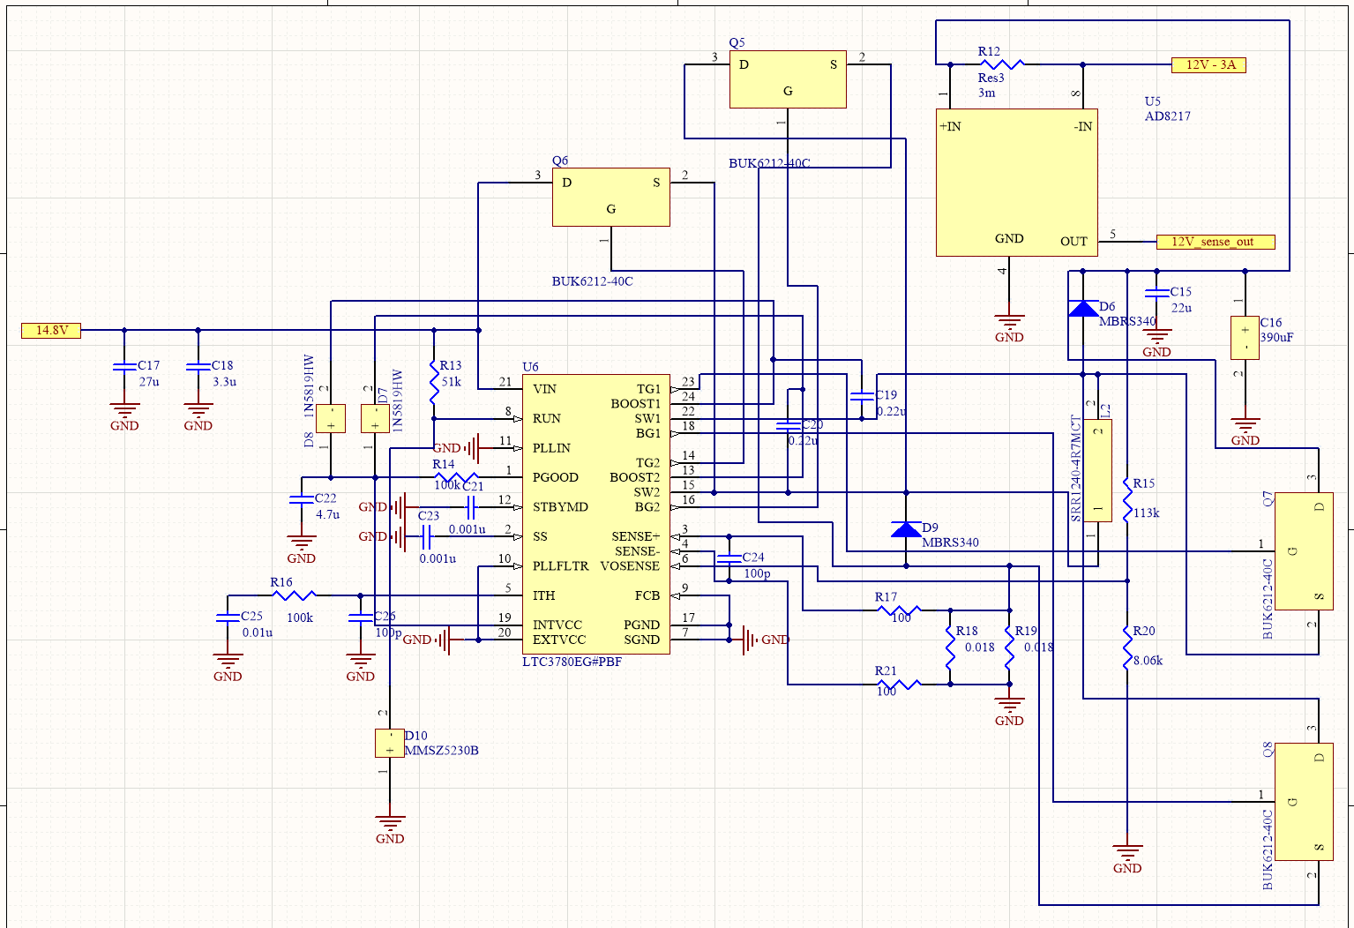

## 19V line

This systems consists of taking the LT3780’s recommended schematic, adding a few decoupling capacitors, and changing the Vosense resistors. The implemented Vosense resistors of 113kOhm and 4.99kOhm provide an output voltage of 18.92V. This device utilizes a 1mOhm sense resistor for its AD8217 to measure current draw as linear voltage based on the current drop across the sense resistor. The PCB layout of this circuit also follows the recommended design from the LT3780’s data sheet for optimal efficiency and ease of design. For further questions, refer to the 9V line for a summary of this system since they are identical besides the boost conversion.

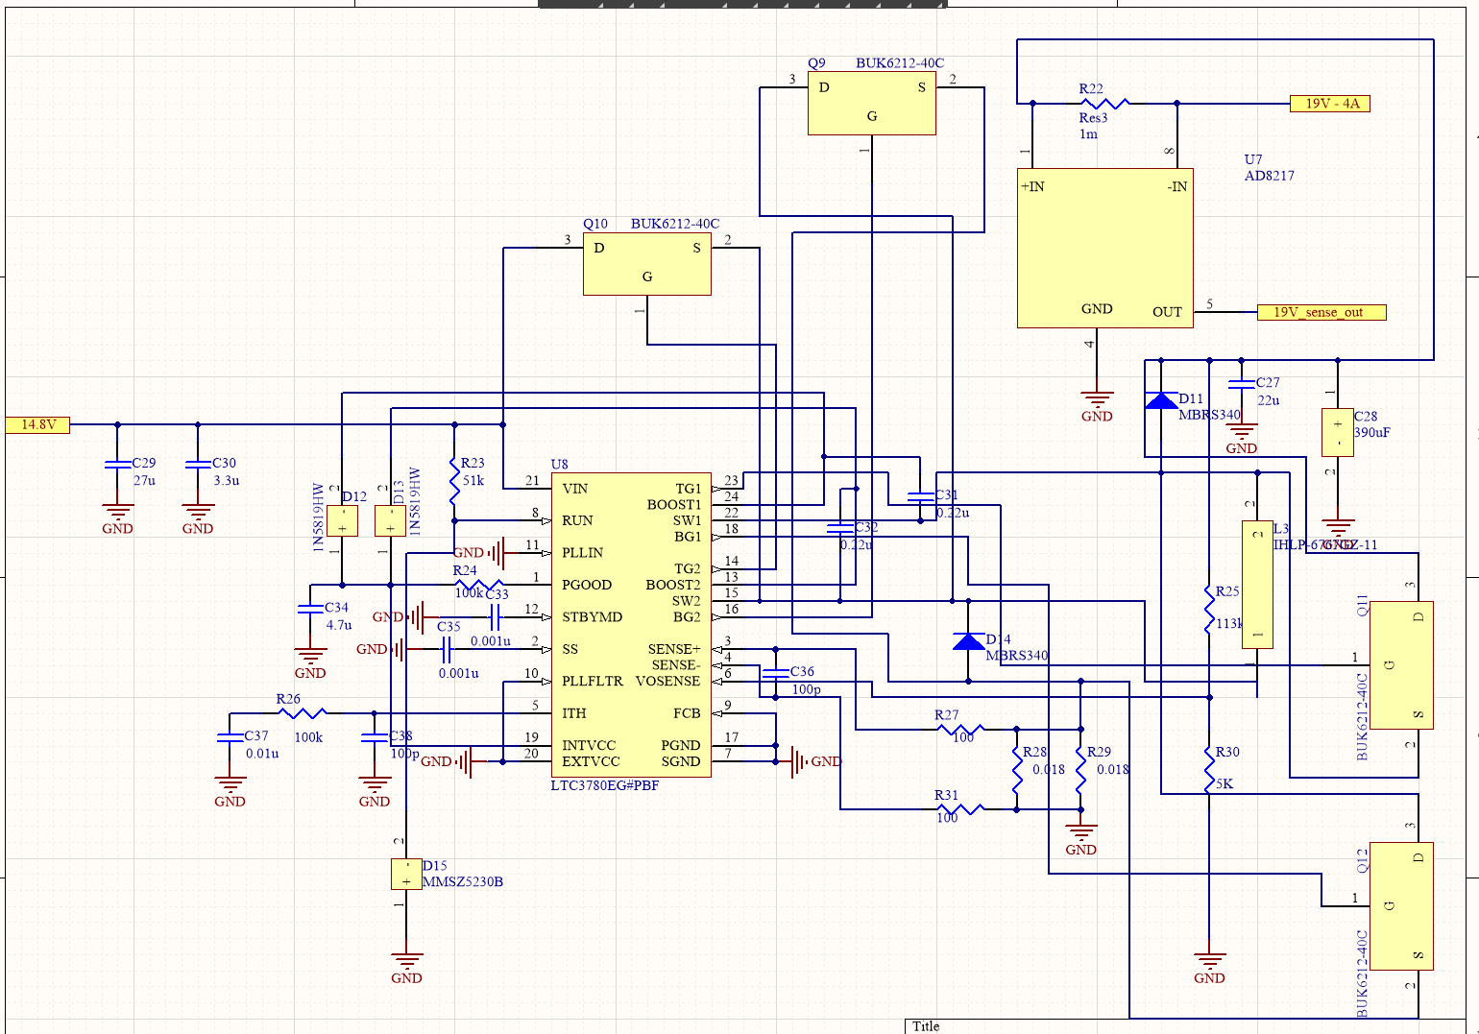

## 48V line

This systems consists of taking the LT3958’s recommended 48V schematic and adding a few decoupling capacitors. Reading the datasheet will be required for complete understanding of this IC. In brief, the voltage is modulated with an inductor and feedback loops through internal regulators, comparators, and a variety of oscillation cycles. This is all followed by a current sensing resistor with a AD8217. This device utilizes a 10 mOhm sense resistor to measure current draw as linear voltage based on the current drop across the sense resistor.

The PCB layout for this system is fully detailed with pictures in the LT3958’s data sheet, so implementation is fairly straightforward. We implemented multiple polygon pours that had no thermal relief/component pad to polygon necks due to the tight clearances of the LT3958 and the system being limited to 0.5 amps. Besides this detail, this layout was basically copied from the datasheet.

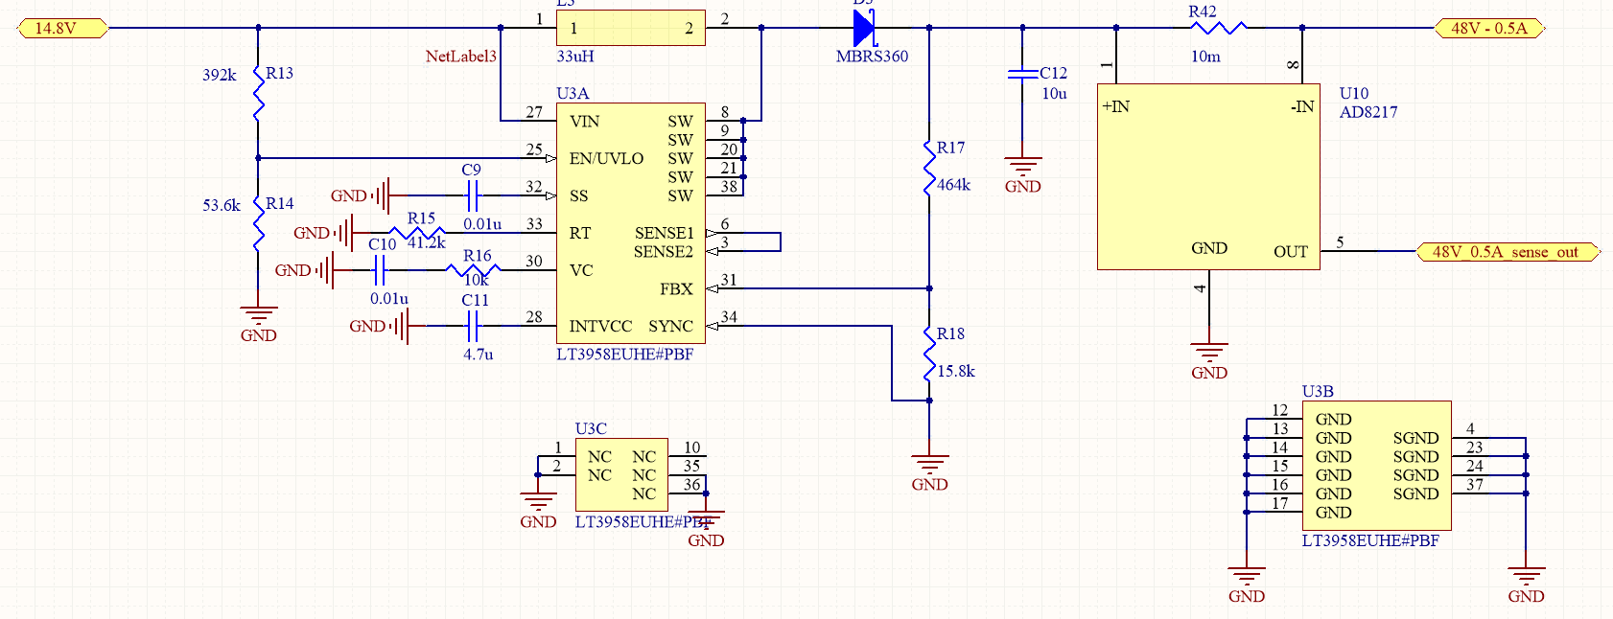

# 

# System status

This system was completed and ran successfully on the 2018 sub Leviathan. No major issues were experienced and further iterations will deal with improving design rather than overhauling the board.

# Known Issues

* Schematic designs are a mess.
* Schematics use big generic box components rather than descriptive component logos.
* Lacking 3D models on PCB layout.
* PCB layout had some incorrectly sized footprints that caused some tight clearances
* No power management for proper startup and shutdown of power lines.
* Recom 5V potentially unreliable and not used for anything.
* No current monitoring to ensure correct operation of sub.
* No voltage monitoring to ensure correct operation of sub.
* Reverse voltage protection only provided by Molex header.
* Not able to properly monitor circuit health or thermals.
* Voltage outputs not exact and worsened with PCB trace resistances.
* No PGOOD monitoring on 9,12,19V lines for voltage accuracy.
* Poor RSense and Inductor selection for current limiting and ripple on 9,12,19V lines.
* PCB layouts and schematics were duplicated by hand instead of utilizing Altium properly.
* Current sense resistors may not guarantee proper linearity of AD8217 outputs.
* Maximum efficiency was not prioritized.

# Appendix

LTC3780: <http://www.analog.com/en/products/power-management/switching-regulators/buck-boost-regulators/external-power-switch-buck-boost/ltc3780.html#product-overview>

LT3958: <http://www.analog.com/en/products/power-management/switching-regulators/flyback-forward-isolated-controllers/lt3958.html>

MicroFit Molex Connector: <https://www.molex.com/molex/products/datasheet.jsp?part=active/0447640801_PCB_RECEPTACLES.xml>